一、【題目說明】：
詳細閱讀“Basys2 七段顯示器”講義，以s410504001_Lab3Demo.v與x7seg.v為基礎，修改為：
1.消除開頭無效的0 。

2.x由實驗板8個指撥開關輸入+學號後2碼。

二、【電路設計與描述】：
完整Verilog code:
module s410504001_Lab3Demo (
input wire [7:0] sw,
input wire mclk,
input wire [3:3] btn,
output wire [0:6] seg,
output wire [3:0] an,
output wire dp );
wire [15:0] x;

// test display value
assign x ={sw,8'h70};

x7seg Xl (
.x (x),
.clk(mclk),
.clr(btn[3]),
.a_to_g(seg),
.an(an),
.dp(dp)
);
endmodule

module x7seg (
input wire [15:0] x,
input wire clk,
input wire clr,
output reg [6:0] a_to_g,
output reg [3:0] an,
output wire dp
);

wire [1:0] s;
reg [3:0] digit;
wire [3:0] aen;
reg [19:0] clkdiv;
assign dp = 1;

// count every __ ms
assign s= clkdiv[19:18];
// enable all digits
assign aen = 4'b1111;

// Digit select: ancode
always@(*) begin
an =4'b1111;
if (aen[s] ==1) an[s] = 0;
if(x[15:12] == 0) an[3] = 1;
if(x[15:12] == 0 && x[11:8] == 0) an[2] = 1;
end

//時脈分頻器(除頻)
always @ (posedge clk or posedge clr)
begin
if(clr==1) clkdiv <= 0;
else clkdiv <= clkdiv + 1;
end

always@(*) //4位4選一 : mux44
case (s)
0: digit = x[3:0];
1: digit = x[7:4];
2: digit = x[11:8];
3: digit = x[15:12];
default: digit = x[3:0];
endcase

// 7段解碼器(hex7seg);
always @(*)
case (digit)
0: a_to_g = 7'b0000001;
1: a_to_g = 7'b1001111;
2: a_to_g = 7'b0010010;
3: a_to_g = 7'b0000110;
4: a_to_g = 7'b1001100;
5: a_to_g = 7'b0100100;
6: a_to_g = 7'b0100000;
7: a_to_g = 7'b0001111;
8: a_to_g = 7'b0000000;
9: a_to_g = 7'b0000100;
'ha: a_to_g = 7'b0000010;
'hb: a_to_g = 7'b1100000;
'hc: a_to_g = 7'b0110001;
'hd: a_to_g = 7'b1000010;
'hE: a_to_g = 7'b0110000;
'hF: a_to_g = 7'b0111000;
default: a_to_g =7'b0000001;//0
endcase

endmodule

三、【電路合成與驗證】：
- 合成(Synthesize)後，使用View RTL Schematic觀察合成電路圖，點選top後進入下一層，將電路圖完全展開後，執行Zoom to full view，擷取電路圖畫面貼於下：
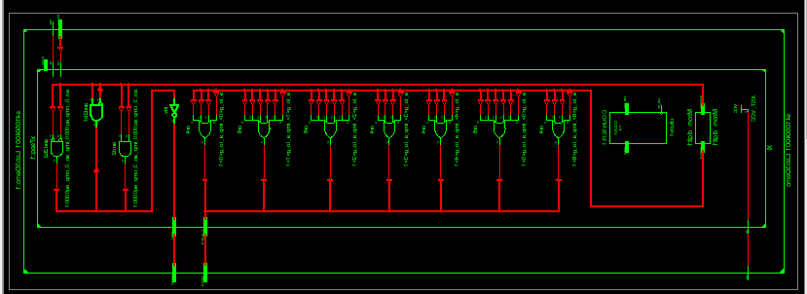
- 使用View Technology Schematic觀察合成電路圖，點選top後進入下一層，並將電路圖Zoom to full view，擷取電路圖畫面貼於下：
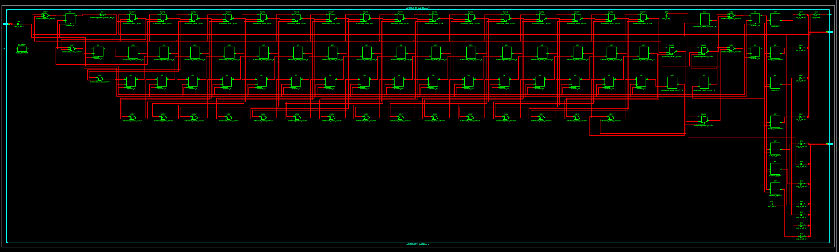
- 實現(Implement)電路後，開啟Design Summary視窗，擷取畫面剪下Project Status、Device Utilization Summary與Performance Summary三個表格。
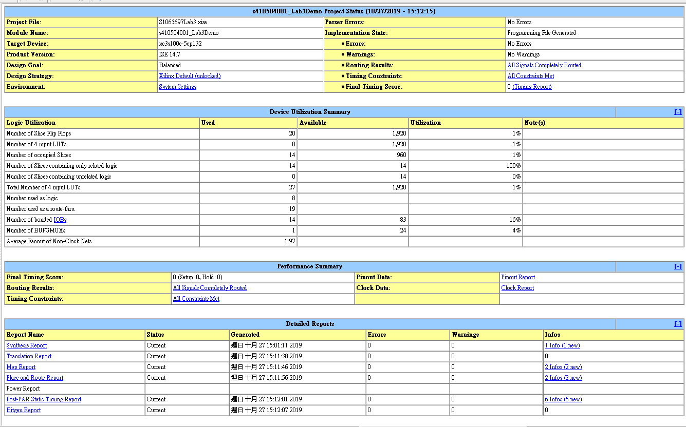
四、Basys2實驗板驗證與結果記錄：
A.指撥開關全部都向下撥的實驗結果，照片貼於下：
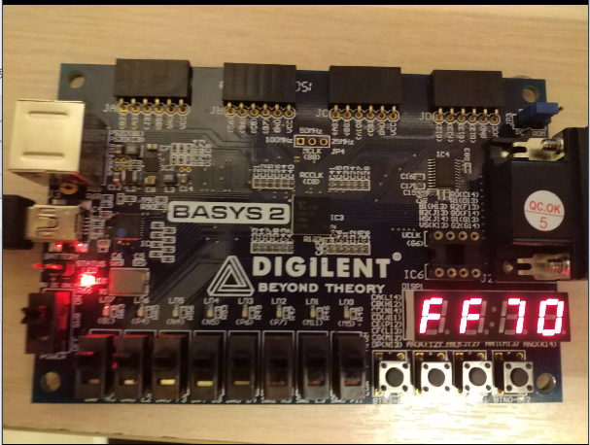
B.指撥開關全部都向上撥的實驗結果，照片貼於下：

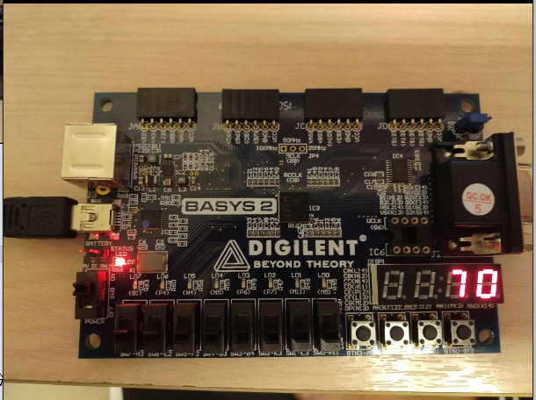
五、basys2.ucf(僅列出有使用的，註解部分移除)
# clock pin for Basys2 Board
NET "mclk" LOC = "B8"; # Bank = 0, Signal name = MCLK
NET "mclk" CLOCK_DEDICATED_ROUTE = FALSE;

# Pin assignment for DispCtl
# Connected to Basys2 onBoard 7seg display
NET "seg<0>" LOC = "L14"; # Bank = 1, Signal name = CA
NET "seg<1>" LOC = "H12"; # Bank = 1, Signal name = CB
NET "seg<2>" LOC = "N14"; # Bank = 1, Signal name = CC
NET "seg<3>" LOC = "N11"; # Bank = 2, Signal name = CD
NET "seg<4>" LOC = "P12"; # Bank = 2, Signal name = CE
NET "seg<5>" LOC = "L13"; # Bank = 1, Signal name = CF
NET "seg<6>" LOC = "M12"; # Bank = 1, Signal name = CG
NET "dp" LOC = "N13"; # Bank = 1, Signal name = DP

NET "an<3>" LOC = "K14"; # Bank = 1, Signal name = AN3
NET "an<2>" LOC = "M13"; # Bank = 1, Signal name = AN2
NET "an<1>" LOC = "J12"; # Bank = 1, Signal name = AN1
NET "an<0>" LOC = "F12"; # Bank = 1, Signal name = AN0

# Pin assignment for SWs
NET "sw<7>" LOC = "N3"; # Bank = 2, Signal name = SW7
NET "sw<6>" LOC = "E2"; # Bank = 3, Signal name = SW6
NET "sw<5>" LOC = "F3"; # Bank = 3, Signal name = SW5
NET "sw<4>" LOC = "G3"; # Bank = 3, Signal name = SW4
NET "sw<3>" LOC = "B4"; # Bank = 3, Signal name = SW3
NET "sw<2>" LOC = "K3"; # Bank = 3, Signal name = SW2
NET "sw<1>" LOC = "L3"; # Bank = 3, Signal name = SW1
NET "sw<0>" LOC = "P11"; # Bank = 2, Signal name = SW0

NET "btn<3>" LOC = "A7"; # Bank = 1, Signal name = BTN3

